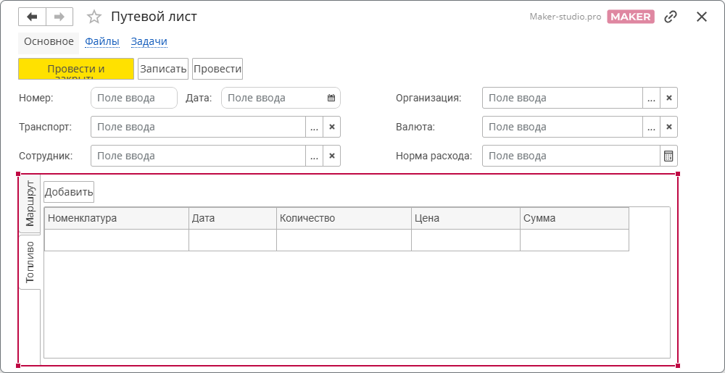

https://design.1cmaker.com/projects/ef78f899-48c1-424e-94f6-7c5f4f4f4530/forms/d023cf97-8616-4908-8c71-13ea7b9502c2

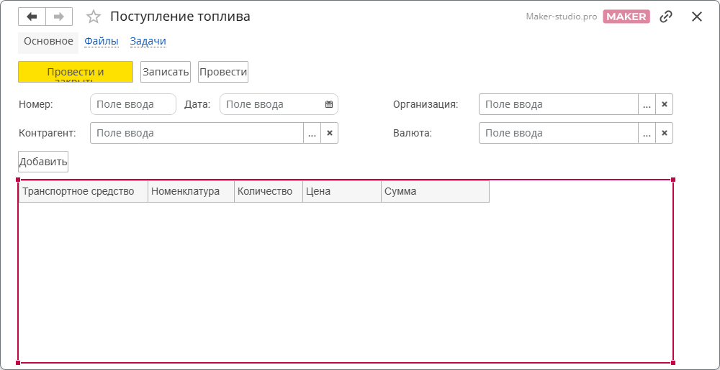

https://design.1cmaker.com/projects/ef78f899-48c1-424e-94f6-7c5f4f4f4530/forms/350b9166-dea2-4631-9db1-59519f6851fe
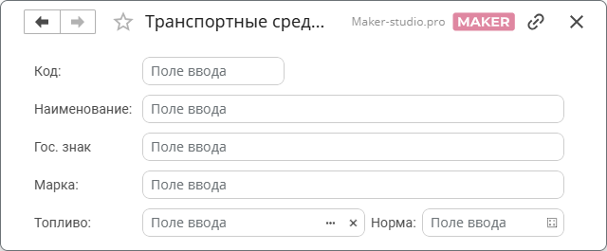

https://design.1cmaker.com/projects/ef78f899-48c1-424e-94f6-7c5f4f4f4530/forms/d980a8a5-4473-47b9-9788-af66897b384d

